|  |  |
| --- | --- |
| 翻译前字数 | 238 |
| 翻译后字数 | 636 |
| 目录 | **Unity Manual/Animation/Animator Controllers/Animation State Machine/State Machine Behaviours** |
| 链接 | <https://docs.unity3d.com/540/Documentation/Manual/StateMachineBehaviours.html> |

**State Machine Behaviours**

**状态机行为**

A State Machine Behaviour is a special class of script. In a similar way to attaching regular Unity scripts (MonoBehaviours) to individual GameObjects, you can attach a StateMachineBehaviour script to an individual state within a state machine. This allows you to write code that will execute when the state machine enters, exits or remains within a particular state. This means you do not have to write your own logic to test for and detect changes in state.

状态机行为是一种特殊的脚本类。类似于添加到个别游戏物体上的Unity脚本（MonoBehaviours），您可以在状态机的某个状态上附加状态机行为脚本。在状态机的进入，退出或者保持在某个状态时执行您的代码。意味着不必编写逻辑用于测试和检测状态的变化。

A few examples for the use of this feature might be to:

使用此功能的几个示例或许可以：

* Play sounds as states are entered or exited
* 在状态进入或者退出时播放声音
* Perform certain tests (eg, ground detection) only when in appropriate states
* 在适当状态时执行某些测试（例如，地面检测）
* Activate and control special effects associated with specific states
* 激活和控制与特定状态相关的特殊效果

State Machine Behaviours can be created and added to states in a very similar way to the way you would create and add scripts to GameObjects. Select a state in your state machine, and then in the inspector use the “Add Behaviour” button to select an existing StateMachineBehaviour or create a new one.

类似于在游戏物体上创建并添加的脚本一样，也可以在状态上创建并添加状态机行为。选择状态机里的一个状态，在展示面板上使用“Add Behaviour”按钮，选择一个存在的状态机行为或者创建一个新的状态机行为。

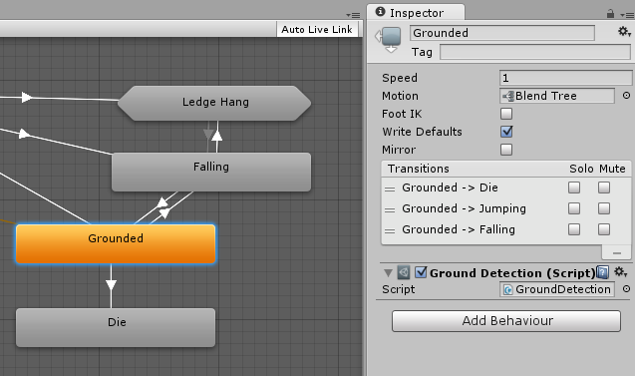A state machine with a behaviour attached to the “Grounded” state

在一个附有行为且名为“Grounded”状态的状态机。

State Machine Behaviour scripts have access to a number of events that are called when the Animator enters, updates and exits different states (or sub-state machines). There are also events which allow you to handle the Root motion and Inverse Kinematics calls.

在动画进入，更新和退出不同状态（或子状态）时，状态机行为脚本可调用多个事件。还有一些事件允许您处理根运动和反向运动学的调用。

For more information see the [State Machine Behaviour](https://docs.unity3d.com/540/Documentation/ScriptReference/StateMachineBehaviour.html) script reference.

更多信息请参阅[State Machine Behaviour](https://docs.unity3d.com/540/Documentation/ScriptReference/StateMachineBehaviour.html) 脚本参考。